TC-CUS-004
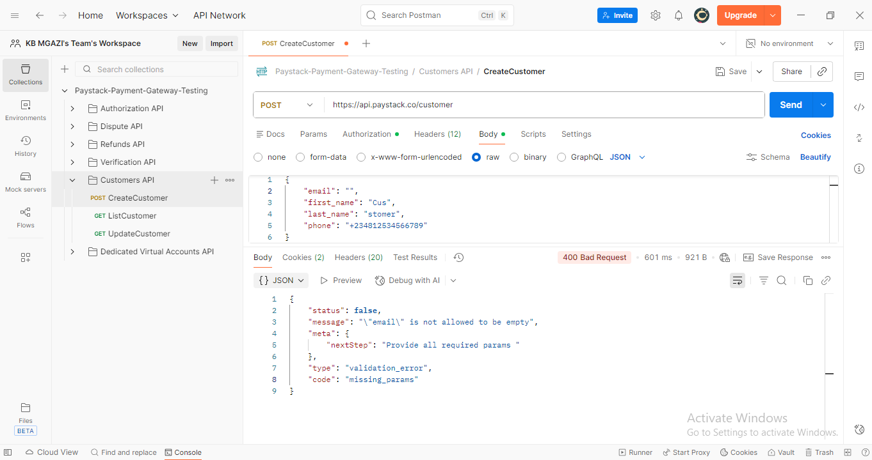
Request:
{
"email": "",
"first_name": "Cus",
"last_name": "stomer",
"phone": "+234812534566789"
}

Response:
{
"status": false,
"message": "\"email\" is not allowed to be empty",
"meta": {
"nextStep": "Provide all required params "
},
"type": "validation_error",
"code": "missing_params"
}

Note**
Customer Name , Surname and mobile number are optional

